# Subset and Conquer - Python Exercise

Below is the image provided along with the recreated question, terminal output, and answer:

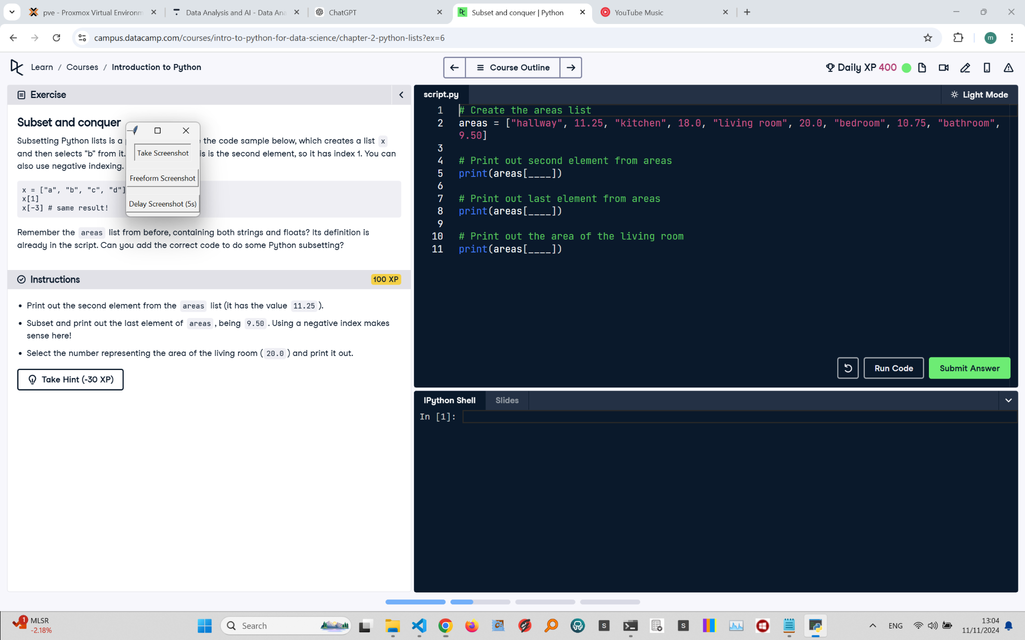

## Recreated Question and Terminal

Subset and Conquer  
Subsetting Python lists is a piece of cake. Take the code sample below, which creates a list x and then selects "b" from it. "b" is the second element, so it has index 1. You can also use negative indexing.

x = ["a", "b", "c", "d"]  
x[1] # selects "b"  
x[-3] # same result!

Remember the areas list from before, containing both strings and floats? Its definition is already in the script. Can you add the correct code to do some Python subsetting?  
  
Instructions:  
- Print out the second element from the areas list (it has the value 11.25).  
- Subset and print out the last element of areas, being 9.50. Using a negative index makes sense here!  
- Select the number representing the area of the living room (20.0) and print it out.

## Answer

# Create the areas List  
areas = ["hallway", 11.25, "kitchen", 18.0, "living room", 20.0, "bedroom", 10.75, "bathroom", 9.50]  
  
# Print out second element from areas  
print(areas[1])  
  
# Print out last element from areas  
print(areas[-1])  
  
# Print out the area of the living room  
print(areas[5])

## Explanation of the Answer

The code uses indexing to access elements in the areas list. areas[1] retrieves 11.25, the second element. areas[-1] accesses the last element, 9.50, using negative indexing. areas[5] retrieves 20.0, the area of the living room. Indexing helps extract specific values efficiently.